FINANCE- FINANCIAL CALCULATIONS Name___________________________________
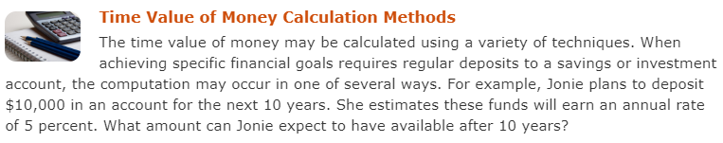

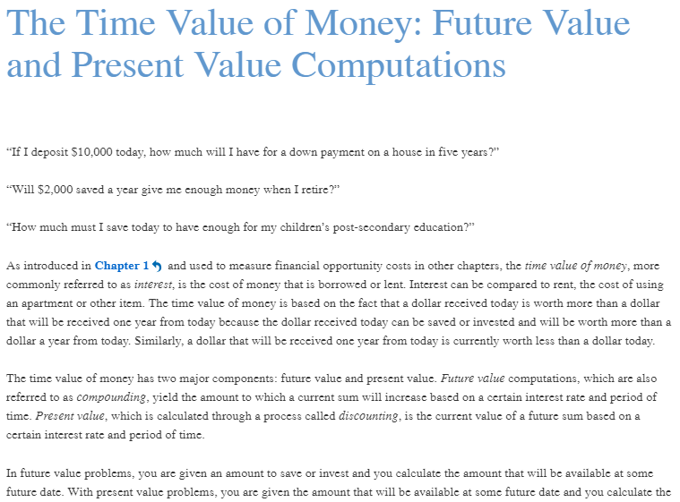

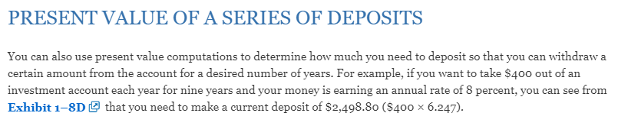

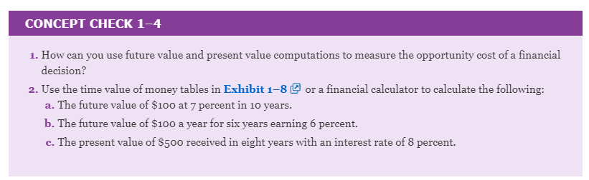

PRACTICE PROBLEMS

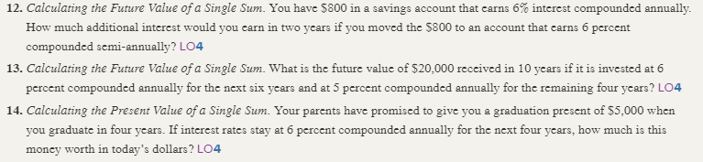

MULTIPLE CHOICE. Choose the one alternative that best completes the statement or answers the question.
1) Assume your uncle will pay you $100 for each of the next two years and $200 in years 3 and these amounts will be paid at year end. Assume the interest rate is 10% for the first two years and 12% for the next two (years 3 and 4). What is your uncle's promise worth in today's dollars? (Round your answer) 1) _______

A) $600 B) $317 C) $512 D) $453 E) $342

2) What is the future value of $20,000 received today, after 10 years if it is invested at 6% compounded annually for the next six years and 5%, compounded semi-annually for the remaining four years? 2) _______

A) $32,772 B) $38,817 C) $25,000 D) $34,567 E) $31,000

3) What is the future value of $30,000 received today, after 10 years if it is invested at 7% compounded annually for the next seven years and 5%, compounded annually for the remaining three years? 3) _______

A) $71,000 B) $54,567 C) $81,744 D) $62,772 E) $55,767

4) What is the future value of $80,000 received today, after 14 years if it is invested at 8% compounded annually for the next five years and 3%, compounded annually for the remaining nine years? 4) _______

A) $171,022
B) $158,098
C) $153,371
D) $134,567
E) $144,772

5) If a person deposited $10,000 earning 9 percent for 11 years, this would involve what type of computation? 5) _______

A) present value of a single amount
B) simple interest
C) future value of a series of deposits
D) present value of a series of deposits
E) future value of a single amount

6) An individual invests $10,000 at a rate of 5% per annum. What will be its value in 10 years' time? 6) _______

A) $15,853 B) $15,000 C) $19,000 D) $18,000 E) $16,289

7) Your goal is to accumulate in 4 years $5,000. If you can earn a rate of 4%, compounded monthly, what will be your end of month monthly payment need to be to reach this goal? 7) _______

A) $124 B) $300 C) $104 D) $96 E) $262

8) Your goal is to pay down your student loan in 3 years. The balance today is $9,434. If you are charged a rate of 4%, compounded monthly, what will be your monthly, end-of-period payment? 8) _______

A) $279 B) $406 C) $300 D) $262 E) $377

9) An individual invests $5,000 at a rate of 5% per annum. What will be its value in 10 years' time? 9) _______

A) $9,000 B) $8,144 C) $9,542 D) $7,500 E) $7,927

10) Assume your friend will pay you $200 for each of the next two years and $400 in years 3 and these amounts will be paid at year end. Assume the interest rate is 10% for the first two years and 12% for the next two (years 3 and 4). What is your friend's promise worth in today's dollars? (Round your answer) 10) ______

A) $951 B) $831 C) $1,000 D) $906 E) $600

11) Your goal is to pay down your student loan in 3 years. The balance today is $9,434. If you are charged a rate of 9%, compounded monthly, what will be your monthly, end-of-period payment? 11) ______

A) $527 B) $406 C) $193 D) $300 E) $262

12) You wish to accumulate $15,000 within five years. How much would you have to save each year for five years to attain your goal? Assume an annual interest rate of 4%. Savings occur at the end of each year. 12) ______

A) $3,500 B) $2,662 C) $3,000 D) $2,905 E) $2,769

13) An individual invests $12,000 at a rate of 4% per annum. What will be its value in 9 years' time? 13) ______

A) $15,853 B) $15,000 C) $18,000 D) $17,080 E) $16,289

14) An individual invests $9,000 at a rate of 6% per annum. What will be its value in 11 years' time? 14) ______

A) $15,000 B) $17,085 C) $18,000 D) $16,289 E) $15,853

15) If a person deposited $100 a month for 5 years earning 9 percent, this would involve what type of computation? 15) ______

A) present value of a single amount
B) present value of a series of deposits
C) future value of a single amount
D) simple interest
E) future value of a series of deposits

